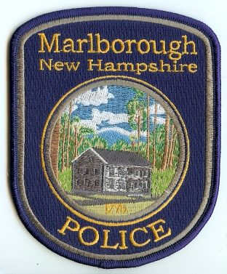
Marlborough Police Department
P. O. Box 487~ 236 Main Street
Marlborough, New Hampshire 03455-0487
Office: (603) 876-3311 FAX: (603) 876-3690
“Equal Opportunity Employer”

Chief Christopher J. Lyons
Officer Zachary D. Byam
Officer Jeremy S. Jeffers
______________________________________________________________________________

REQUEST FOR COPY OF POLICE REPORT

Name: __________________________________________________________________ DOB: ___________________________

Address: _______________________________________________________________ Tel. No. _________________________

Mailing Address: ____________________________________________________________________________________________

I hereby request a copy of the following police report(s):

______ Accident ______ Arrest ______ Incident ______ Domestic Violence Incident/Arrest (if you are the victim)
______ Other ______________________________________________________________________________________________________

The following are the established fee(s) for providing reports:

1 to 25 pages $15.00
26 to 50 pages $20.00
51 to 150 pages $30.00
151 to 200 pages $40.00
200+ pages $40.00
(plus 10 cents per page over 200)
Video $25.00
CD/Audio $15.00
Diskette $ 2.00
Photographs Cost of Reproduction
Domestic Violence Victims No Charge for Reports

An invoice will be included with the report. Please allow five days for delivery. The report will be mailed to you at the mailing address you have indicated above. You may pick up the report at the police department by making prior arrangements. Please call ahead to ensure someone will be available to assist you.

Date of Request: ___________________________ Signature: __________________________________________________

*** Please note that insurance companies routinely request and pay for copies of reports on any claims that you make with them. Please consult with your insurance company as to whether or not they have already requested a copy of a report on this incident. We are happy to provide a copy of any report to you, however, you will be billed for a copy of this report even if your insurance company has already received a copy and is billing you for it.

